Songs:
God is For Us
How Deep the Father's Love for Us
His Glory and My Good
Mighty, Mighty Saviour
Grace Awaiting Me

God is For Us by CityAlight

[Intro]
|D / / /|G / / /|
|D / / /|G / / /|

[Verse 1]
D G D
We won't fear the battle, we won't fear the night
G D Bm A
We will walk the valley with You by our side
D G D
You will go before us, You will lead the way
G D Bm A
We have found a refuge, only You can save

[Chorus]
D G D
Sing with joy now: our God is for us
G D Bm A
The Father's love is a strong and mighty fortress
D G D
Raise your voice now, no love is greater
G D A
Who can stand against us if our God is for us

[Intro]
|D / / /|G / / /|

[Verse 2]
D G D
Even when I stumble, even when I fall
G D Bm A
Even when I turn back, still Your love is sure
D G D
You will not abandon, You will not forsake
G D Bm A
You will cheer me onward with never-ending grace

CHORUS

[Intro]
|D / / /|G / / /|
|D / / /|G / / /|

[Bridge]
G A
Neither height nor depth can separate us
Bm D/F#
Hell and death will not defeat us
G A
He who gave His son to free us
Bm A
Holds me in His love
G A
Neither height nor depth can separate us
Bm D/F#
Hell and death will not defeat us
G A
He who gave His son to free us
Bm A
Holds me in His love

CHORUS X2

[Outro]
|D / / /|G / / /|
|D / / /|G / / /|

[End]
D

Intro:
F# F# D G G G
F# F# D G G G
HOW DEEP THE FATHER’S LOVE
FOR US D
INTRO
Verse 1 first 2 lines chords and Cello solo

VERSE 1
D Em - D/F# G D
How deep the Father's love for us, how vast
Bm A
beyond all measure
D Em - D/F# G D
That he should give his only son, to make a
A D
wretch his treasure
Bm G D
How great the pain of searing loss, the Father
Bm A
turned his face away
D Em - D/F# G
As wounds which mar the chosen one, bring
D A D
many ones to glory

Bm.. A. D. x2

VERSE 2
D Em - D/F# G
Behold the man upon a cross,
D Bm A
my sin upon his shoulders
D Em - D/F# G
Ashamed, I hear my mocking voice
D A D
call out among the scoffers
Bm G
It was my sin that held him there
D Bm A
until it was accomplished
Bm Em - D/F# G
His dying breath has brought me life;
D A D
I know that it is finished

INSTRUMENTAL
Bm A D x4

VERSE 3 (Build)
D Em - D/F# G
I will not boast in anything:
D Bm A
no gifts, no power, no wisdom
Bm G
But I will boast in Jesus Christ;
D A D
his death and resurrection

Bm Em - D/F# G
Why should I gain from his reward?
D Bm A
I cannot give an answer
Bm G
But this I know with all my heart:
D A D
his wounds have paid my ransom

SOFT
Bm G
Why should I gain from his reward?
D A
I cannot give an answer
D G
But this I know with all my heart:
D A D
his wounds have paid my ransom

[End]
D G
But this I know with all my heart:
D A D
his wounds have paid my ransom

Verse 1 first 2 lines chords and Cello solo
D major
D F, DEFEDB
AA,DDFFE,
D F, DEFEDB
AA,DDFED
His Glory and my good
Intro
Asus2 E B C#m7 x2

Verse 1
Asus2 E
I have seen my Father’s glory
B C#m7
Revealed in Jesus Christ
Asus2 E
And the more that I behold Him
B C#m7
The more He satisfies
A E
When I gaze upon His beauty
B C#m7
When I see Him as I should
Asus2 E/G#
Then my eyes are lifted upward
B Asus2 E B C#m7
For His glory and my good

Verse 2:
Asus2 E
There is hope in every trial
B C#m7
For I can trust the Lord
Asus2 E
He will turn my heart towards Him
B C#m7
And help me bear the thorn
A E
So in faith I follow Jesus
B C#m7
On the road not understood
Asus2 E/G#
For I know that He is working
B E5 A4
For His glory and my good

Chorus 1
E
To our God be the glory
A E
To our God be praise
C#m7 B
He alone, the name above all names
E/G# A C#m7
I will boast ever only in the Lord my God
A B Asus2 E B C#m7
For I know His glory is my good

Verse 3:
Asus2 E
See the open arms of Jesus
B C#m7
Upon the cross that day
Asus2 E
What they understood as weakness
B C#m7
Deserves my every praise
A E
For the charge that was against me
B C#m7
It was nailed into the wood
Asus2 E/G#
Yes I know that He has saved me
B E
For His glory and my good
CHORUS
Instrumental: A E/G# C#m7 B x4
Verse 4:
Asus2 E
Would I gladly be made nothing
B C#m7
That Christ would be made more
Asus2 E
Would I seek the only kingdom
B C#m7
That far outweighs them all
A E
I will stand before my Father
B C#m7
Where the faithful saints have stood
Asus2 E/G#
And with joy my heart shall praise Him
B E
For His glory and my good

CHORUS
A B C#m7
For I know His glory is my good
A B
For I know His glory is my good

Ending: Asus2 E B E
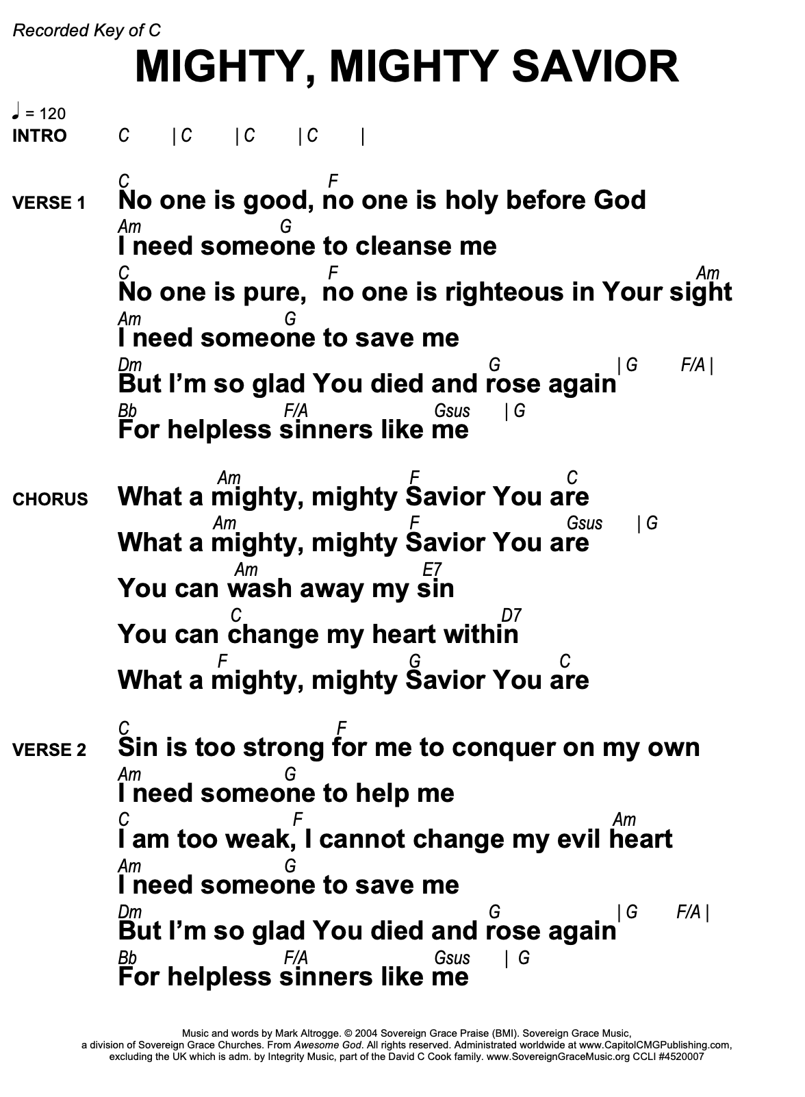
Grace Awaiting Me

Verse 1
A
I will see the world to come
F#m
For one has suffered in my place
D A
Now there is grace awaiting me, awaiting me.
A
Judgement's done, atonement's made
F#m
The ransom's paid, no guilt remains
D
Now there is grace awaiting me, awaiting
A
me!

Chorus
D F#m
Grace - a welcome from the Father
D F#m
Grace - forgiveness full and free
D F#m
Grace - that's greater than our failings
E D A
Oh there is grace awaiting me

Verse 2
A
I take comfort in the hope
F#m
Of the thief upon the cross
D A
For I am worthy of as little love as he.
A
Like this man, I won't despair
F#m
For life's ahead, what joy we'll share
D A
Now there is grace awaiting me, awaiting me!
CHORUS

Bridge
A E/G#
Jesus you have loved and bought me
F#m D
By your death my debts are paid
A E/G#
I am yours, I stand beside you
F#m D
Fearless face the coming day.

Verse 3
A
I will see the world to come
F#m
Despite the sin that I have done
D A
For there is grace awaiting me, awaiting me.
A
All who call upon the Lord
F#m
Will rise to life with peace assured
D A
For there is grace awaiting me, awaiting me.

CHORUS

